**INTRODUCTION**

**Background of the Study**

The society has been dramatically changed with the evolution of technology. Election is the process of voting to choose someone to be a leader. Voting application on election process is very useful in any place of the world. As stated by Lozano, (2014), the previous election of Supreme Student Government in Bohol Island State University is encountered problems, especially on the inconvenience of students in getting in line at their assigned precinct to cast their votes. Solve such problem mobile voting system, was established.

In every school, an election is conducted to have student leaders who will lead them in the whole year. Most of the school are using manual system for electing student leaders.

The Agusan del Sur State College of Agriculture and Technology (ASSCAT) is currently using traditional way the manual process which is prone to errors and are definitely slow in generating result because they have to tally the votes casted by the student.

This study aims to facilitate the election process of ASSCAT. There will be a database provided for all students to vote and for all candidates to run for election with their complete information.

Candidates can also vote in any position. The system use real-time process to update the votes of every candidate.

**Objective of the Study**

The general objective of this project is to develop a voting application for student in ASSCAT in election period.

Specifically, this project aims to:

1. Provide candidate profiling for validation of position to run. The comelec can only validate the candidate profile in every position.

2. View the votes in every position using real-time update.

3. Generate summary of reports of the votes casted per position.

**Significance of the study**

The Agusan del Sur State College of Agriculture and Technology Supreme Student Government Voting Application will help in the casting of votes and speedy retrieval of results during SSG election.

The system will be significant to the following:

The ***Students.*** The study is beneficial to the students to make it easy, efficient and convenient voting.

The ***Candidates.*** The study is beneficial to the candidates to ensure fair and accurate process of election.

The ***SSG Officers.*** The study is beneficial to the SSG officers to help them reduce tremendous workload of casting and counting votes, and generating the results and reports of the election

The ***Researchers.*** The study is beneficial to the researchers in applying their skills and in learning new knowledge in developing the system automation.

The ***Future Researchers.*** The study is beneficial to the future researchers it serves them as a guide and reference for the future students.

**Scope and Delimitation**

The scope of the system is to create a desktop voting application that will provide candidate profiling as mandated in the Constitution and By-Laws of the Supreme Student Government (SSG). The system aim to secure and avoid manipulating the tally of votes in the SSG election process in Agusan del Sur State College of Agriculture and Technology (ASSCAT). The system will require the students’ I.D number for them to log-in in the system and cast their votes. Thus, the system will also identify the students who voted or not during the election. Real-time view of the voters in every position will be provided also by the system. But the votes that will be garnered by every­­­­ candidate are visible only by the COMELEC until the election period is over. The system will only be implemented at ASSCAT CULTURAL CENTERduring Election Day.

**Time and Place of the study**

This study was conducted at Agusan del Sur State College of Agriculture and Technology (ASSCAT) Main Campus, Bunawan, Agusan del Sur during Academic year 2018-2019.

**Operational Definition of Terms**

**ASSCAT** - school being conducted.

**SSG** – a student organization that implement school programs, activities and projects.

**Voting** - it’s a polling system that every individual choose their perspective candidate.

**Application –** it is a type of software that allows you to perform a specific task.

**Database –** is storage of data in a computer that can fastly update and retrieve information.

**Mysql –** is open source application software that can store and retrieve data.

**Student –** refers to the person who votes.

**Comelec –** refers to the rulers in the election pro

**Conceptual Framework**

The conceptual framework shows how will be the process of the application. In Figure 1, the user will get to know how the project functions and operates. It also shows feasible development of the developed study.

**ASSCAT SSG Voting Application**

Knowledge Requirements:

* Student Info.
* Candidate

Info.

Software Requirements:

* Xampp v5.6.33
* MySQL v4.7.4
* PHP v5.6

Hardware Requirements:

Computers

Requirements Definition:

* Preliminary of study

System and Software Design:

* System designing and software building

Implementation and Unit Testing:

* Initializing and unit testing for errors

Integration and System Testing:

* Integrating the program modules and testing for errors

Operation and Maintenance:

* The system is already installed and enhancement is expected

Figure 1. Conceptual Framework

**REVIEW OF RELATED LITERATURE, STUDIES and SYSTEMS**

Every school need a student leader or representatives especially in the colleges. According to the ASSCAT BY-LAWS Article I, Section I, State that “The organization established herein under this constitution shall be known as the Supreme Student Government and its acronym shall be SSG”. The Supreme Student Government builds on 1993 and continued to serve as voice of the student body. It is their duty to advocate camaraderie for the interest of the student.

Voting is an opportunity to exercise democratic right; every individual has the freedom to choose a candidate that best represents their views. In this way, the voter’s welfare will be decided by the decision they will make in voting.

**Philippines Smart App Voting System**

Philippines is a democratic country. Voting is a practice of democracy for the last decades up to present. The country is currently using paper-based and Prescient Count Optical Scanner or PCOS machine by Smartmatic in which there are several issues during 2016 election. The said machine has a loss of signal in remote areas in some provinces in the Philippines. It caused data traffic and failure to transmit poll data from 18,000 precincts. Incorrect shading of votes make it unreadable, and will probably result to paper jam (Abamo et.al, 2016).

**Campus E-Voting for Android and Web Based Application**

Voting is very important in any current democratic societies. The objective of the project is to intend a voting process, which voters can cast and secure their votes over a network since manual voting process is time consuming and counting of votes may lead to inaccurate data and unreliable results. E-voting should be implemented since it reaches the user requirements satisfactory. This is done by android application which will accept the votes of different student using application and web application. Campus E-voting will make the voting process very easy and efficient. Campus E-voting is very appealing to the students to participate and provide interaction between the voters and the candidates (Pandit, 2014).

**Helios: Web-based Open-Audit Voting**

Open-audit voting is voting with cryptographic auditing. Helios presents a web-based open audit voting system. Using a modern web browser, anyone can set up an election, invites voters to cast secret ballots, compute a tally, and generate a valid proof for the entire process. Cryptographers have developed election protocol that promises a radical paradigm shift: election process can be checked entirely by public observers and at the same time preserving voter’s secrecy (Adida, 2013).

**Fingerprint Voting System Using Arduino**

Nowadays, voting for general and local election is done by electors with polling papers and polling boxes in which the polling papers are placed. This kind of method reveals negative situations. Some problems include fraud by the election personnel and mistakes made in counting the votes. In order to avoid these problems, E-voting was introduced by the researchers. As a result, fingerprint voting system is greatly improved by using biometric authentication system (Piratheepan et.al, 2017).

**A mobile web based electronic voting system**

Paper ballots bring problem such as: slow rate of counting and tabulation of casted votes, inaccurate result due to the humans’ errors, and inconvenience for the voters with their votes, fraud in polling stations during the transmission and tabulation of votes. The mobile web based electronic system is secured by the use of hashing public key encryption and secure electronic transmission Protocol. The system was tested at the Strathmore University, students who interacted with the system and answered the survey questionnaires (Omondi, 2015).

**Efficient E-voting Android Based System**

An efficient e-voting android based system will provide two general block diagram to secure collection and processing system. The system directed to need for real-time functionality of voting process to secured collection and processing system the total votes and monitors ballot irregularities. The election authorities can access the secured processing system and server to monitor ballots irregularly to assure that ballot are being properly used and counted (Mohammed, 2013).

**Methodology**

The researchers used Modified waterfall model as their process model. The Modified Waterfall method is fit in our study due to its flexibility. This presumes that the researchers will coordinate with the business and technical entities to define both functional and non-functional requirements. It enables the phases to overlap when needed.

**Requirements Analysis**

**Design**

**Implementation**

**Testing**

**Maintenance**

Figure 2. Modified Waterfall Model

The principal stages of the waterfall model activities are as follows:

1. **Requirements Analysis:** The process of creating a plan of ASSCAT Voting Application in ASSCAT at Bunawan, Agusan del Sur. Based on interviews and observation to the ASSCAT personnel particularly the office of SSG, the study was conceptualized. System and user requirements were identified.
2. **Design:** In this phase, the researchers are going to visualize some of the gathered information based on the target on the user on what is their preferred design in the project system. And what is the best interface that the researchers should do to make the project system attractable.
3. **Implementation:** This phase is the start of coding session. The researcher will start to develop the system. The system developed and tested by the researchers for its functionality.
4. **Testing:** The integration of the components, tools, units and programs. The system will be tested to insure that the system is completely functional and will be implemented in ASSCAT Main Campus.
5. **Maintenance:** To connect some functionality of the flow of the system. Fixing the errors that is not recovered earlier; to improve the system and preventing it from further problems; to be encountered and to obtain solutions of it.

**Requirement Specification**

**User Requirements**

The establishment of ASSCAT SSG Voting Application was pursued to have an automated voting of systematic way as the following:

* Security
* Accurate election process

**Functional Requirements**

Admin

* Log in with username and password
* Admin will encode all the validated candidates
* Admin can see the summary of generated result

User

* Log in with
* Cast their votes

**Non-Functional Requirements**

* The system can operate in the computer.
* The system is useful and easy to use.
* The system will integrated in future if need be.

**Software and Hardware Requirements**

Software Requirements:

* Xampp v5.6.33
* MySQL v4.7.4
* PHP v5.6

Hardware Requirements:

Computer

**Feasibility Issues**

The following feasibility issues were created to test the proposed system. The feasibility analyses are as follows:

**Economic Feasibility.** A traditional approach shows that the ASSCAT SSG Voting Application has a good chance to implement in Agusan del Sur State College of Agriculture and Technology.

Intangible Costs and Benefits:

1. Help the students achieve peace of mind in casting votes during voting election.
2. It consumes less paper to be used in voting, thus it produces less waste.

**Technical Feasibility.** Based on the observation in the ASSCAT ICT Laboratory, the researchers found out that this alternative is technically feasible because the ICT Lab had already computer units. If there would be a problem in the system, the user can directly approach the developer to make the problem fixed as soon as possible.

**Operational Feasibility.** The researchers are planning to make a desktop application because the system is a user friendly, thus, user satisfaction is guaranteed during the election process.

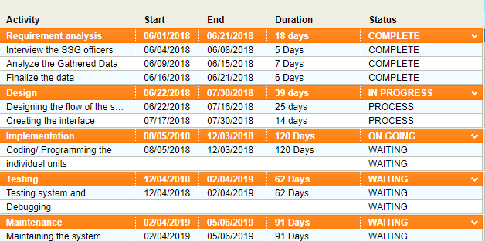**Schedule Feasibility**

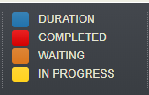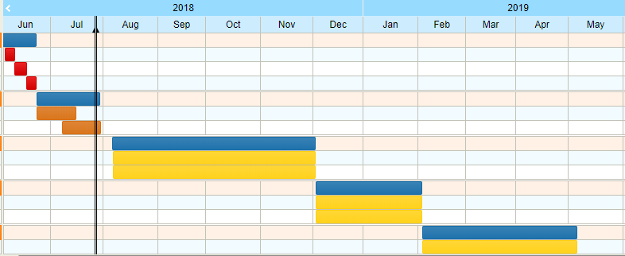

Figure 3. Schedule Feasibility

**Project Cost**

In this capstone project entitled ASSCAT SSG Voting Application will be made possible with the help of the technical writer for documentation, document editor, analyst, programmer, grammarian and English critic; the total cost of this project is more or less twenty thousand pesos (23­­­­­­­­, 000).

**Work Breakdown Structure**

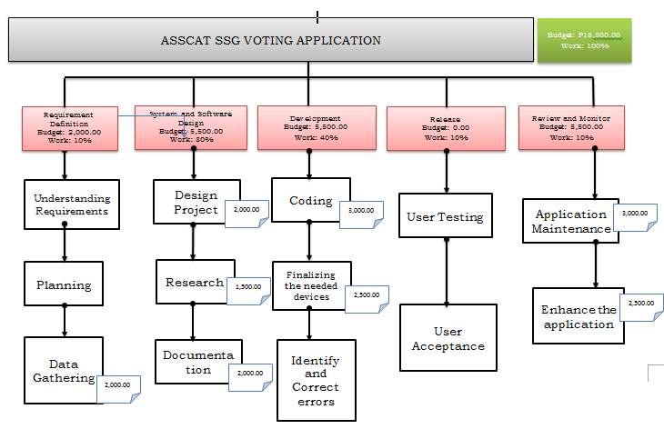 This figure shows the cost in every phase on how the researchers develop and maintain the system. This figure will be the guide on how the expenses divided.

Figure 4. Work Breakdown Structure of the study

**Project Benefit Analysis**

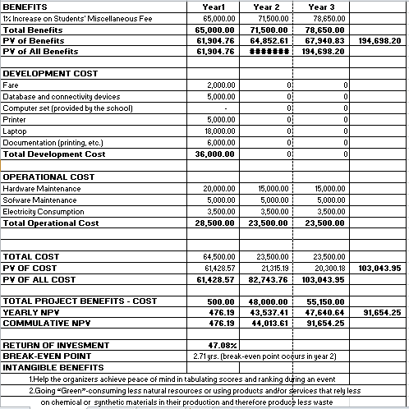The Cost Estimate is an important consideration in creating a project to know the estimated cost in this project. The table below shown the cost estimated on the implementation and system development.

Table 1. Project Cost Estimated

**Risk Analysis**

ASSCAT SSG Voting Application possibly encounters the following risk during the operation of the system.

|  |  |  |  |  |  |  |
| --- | --- | --- | --- | --- | --- | --- |
| **RISK** | **LEVEL** | **DESCRIPTION** | **POTENTIAL INDICATOR** | **EFFECTS** | **STRATEGY** | **STATUS** |
| 1.System Failure | High | The performance of the system did not satisfy the requirement. | The system cannot execute some basic function | The developer needs to look back and review the codes which cause delay to the transaction. | The developer need to have consultation, research and fix the system. |  |
| 2. Database Failure | High | Difficulties in retrial of data and files. | When database have problem and it cannot work properly | Having difficulties in retrieving data and files | Provide a database which has a security access that cannot easily intrude. |  |
| 3.Unfamiliarity of the system | High | The user have no idea if how it works | The user will cannot access the system if don’t know the procedure | It will possibly produces error to system | The user should trained and practice the procedure of the system. |  |

Table 2. Risk Analysis

**Implementation of the System**

The system to be implemented is following arrangement of steps. All the desktop computer of school must be installed with this app in order to the user to register and to cast their votes through this. Admin can only get the summary votes of every candidate.

**Deployment Diagram**

This figure 5 shows the flow of deployment of the system and also the flow of the system.

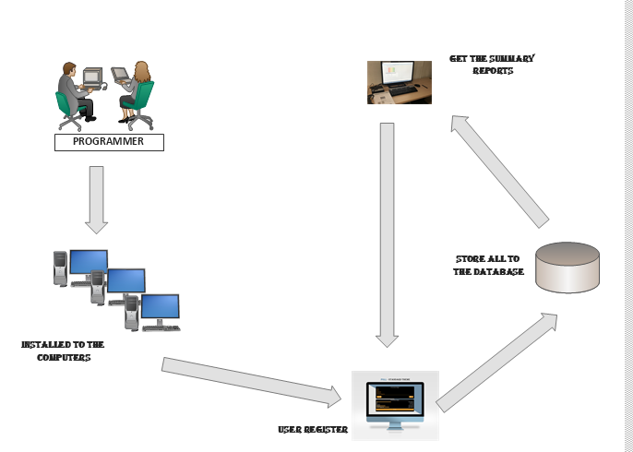

Figure 5.Deployment Diagram

**LITERATURE CITED**

Abamo, J.L, M.R. Abamo and T.D. Valerio (2016). “Philippines Smart App Voting System a Mobile Voting System”. International Journal of Advanced Research in Computer Science and Software Engineering Vol.6, Issue 3. Retrieved on March 2016, from <http://ijarcsse.com/Before_August_2017/docs/papers/Volume_6/3_March2016/V6I3-01301.pdf>

Adida B, (2013). “Helios: Web-based Open-Audit Voting”. Harvard University. Retrieved on from <https://www.usenix.org/legacy/event/sec08/tech/full_papers/adida/adida.pdf>

Mohammed Dr. A.A and R.A Timour (2013). “ Efficient E-voting Android Based System”. International Journal of Advanced Research in Computer Science and Software Engineering International Journal of Advanced Research in Computer Science and Software Engineering Vol. 3, Issue 11. Retrieved on November 2013, from https://pdfs.semanticscholar.org/881b/625d2d036cdaa98e6a6ee332bd451ad403f3.pdf?_ga=2.115936078.994491712.1533794111-774045653.1533794111

Omondi G.P., (2015). “A mobile web based electronic voting system.” Electronic Theses and Dissertations. Retrieved on June 2015, from <https://su-plus.strathmore.edu/bitstream/handle/11071/4870/Gregory%20Peter%20Omondi.pdf?sequence=2&isAllowed=y>

Pandit P., S. Bhawar, Prof. Manisha Desai (2014). “Campus E-Voting for Android and Web Based Application”. International Journal of Emerging Engineering Research and Technology Vol. 2, Issue 7. Retrieved on October 2014, from <http://www.ijeert.org/pdf/v2-i7/13.pdf>

1 11 1

M. Nathiya, C. Sivakaran, N. Thiruchchelvan and K. Thiruthanigesa

Piratheepan A., S. Saksikaran, P. Thanushkanth, S. Tharsika, M. Nathiya, C. Sivakaran, N. Thriruchchelvan and K. Thiruthanigesan (2017). “Fingerprint Voting System Using Arduino”. Middle-East Journal of Scientific Research. Retrieved on December 2017, from <https://www.researchgate.net/publication/322789967_Fingerprint_Voting_System_Using_Arduino>

**APPENDICES**

**CURRICULUM VITAE**

**PERSONAL BACKGROUND:**

Name: Benpaul G. Cabalo

Nickname: Paul

Position: Programmer / Document in Charge

Birthdate: March 20, 1998

Birthplace: Prosperidad, Agusan del Sur

Address: P-5 Poblacion, Prosperidad Agusan del Sur

E-Address: cabalobenpaul[@gmail.com](mailto:salliesaiz08@gmail.com)

Father: Benjamine Cabalo

Mother: Josephine Cabalo

Religion: Roman Catholic

Motto: “The true handsome is in me.”

**EDUCATIONAL BACKGROUND:**

Elementary Graduated: East Prosperidad Agusan del Sur

Secondary Graduated: Monato Institute of Technology

**CURRICULUM VITAE**

**PERSONAL BACKGROUND:**

Name: Jennifer K. Caruz

Nickname: Jenn

Position: Researcher /Document in Charge

Birthdate: November 8, 1997

Birthplace: Patin-ay, Prosperidad Agusan del Sur

Address: Bucac, Bayugan Agusan City

E-Address: [caruzjennifer@gmail.com](mailto:caruzjennifer@gmail.com)

Father: Leopoldo A. Caruz

Mother: Nena K. Caruz

Religion: Roman Catholic

Motto: “Beauty is not found in me but my personality will bring you to remember me.”

**EDUCATIONAL BACKGROUND:**

Elementary Graduated: Bucac Elementary School

Secondary Graduated: Bayugan National Comprehensive High School